Optimizing Temporal Efficient Networks for Embedded Keyword Spotting on Microcontrollers

Abstract — Keyword spotting (KWS) is a key enabling technology for voice-driven interfaces in embedded and Internet-of-Things (IoT) devices. Deploying deep learning models for KWS directly on microcontrollers is challenging due to strict constraints in memory capacity, computational resources, and energy consumption. In this work, we investigate the optimization of a lightweight neural network architecture for embedded keyword spotting applications. Specifically, we focus on improving the Temporal Efficient Network (TENet) architecture through systematic architecture exploration and hyperparameter optimization. Five candidate architectures are evaluated under a fixed computational budget, and TENet is selected as the most efficient base model. A four-stage progressive grid search is then performed over six architectural hyperparameters, evaluating 2,302 candidate configurations. The optimized model is trained using the Google Speech Commands v2 dataset with data augmentation techniques including SpecAugment, Mixup, and label smoothing, and deployed on an STM32F767IGT6 microcontroller based on the ARM Cortex-M7 architecture. Experimental results show that the proposed model achieves a test accuracy of 96.84% (96.76% after INT8 quantization) and a weighted F1-score of 0.9675 with only 12,822 parameters and 276,136 multiply-accumulate operations (MACCs). The deployed INT8 model requires 13.87 KB of flash memory and 7.64 KB of RAM, and achieves an average inference latency of 6.32 ms on the target hardware. Compared with previously reported lightweight keyword spotting architectures operating under similar computational constraints, the optimized TENet model achieves improved classification performance while maintaining a compact footprint suitable for real-time embedded deployment.
Keywords — Keyword spotting, TinyML, embedded AI, microcontroller, TENet, speech recognition, edge computing, neural architecture optimization.

I. Introduction
Keyword spotting (KWS) is a speech processing task that detects predefined keywords from a continuous audio stream. It forms the foundation of voice-driven interfaces used in many modern applications such as smart speakers, wearable devices, and Internet-of-Things (IoT) systems [1]. In these applications, a lightweight KWS module continuously monitors incoming audio signals and activates higher-level processing only when a specific command or wake word is detected. This mechanism enables intuitive human–machine interaction while reducing unnecessary computation.
With the rapid growth of edge computing and IoT technologies, there is increasing demand for deploying speech recognition algorithms directly on embedded devices. Running KWS locally on edge hardware offers several advantages, including reduced latency, improved privacy, and lower communication overhead since audio data does not need to be transmitted to cloud servers [2]. However, implementing deep learning models on microcontrollers remains challenging due to strict constraints in memory capacity, computational power, and energy consumption [3].
To address these constraints, recent research has focused on developing lightweight neural network architectures for embedded keyword spotting. Zhang et al. [2] proposed depthwise separable CNN (DS-CNN) models specifically designed for microcontroller deployment, demonstrating real-time keyword spotting on ARM Cortex-M processors. Li et al. [4] introduced the Temporal Efficient Network (TENet), which uses multi-scale temporal convolutions to efficiently capture temporal patterns in speech signals. Kim et al. [5] proposed BC-ResNet with broadcasted residual connections, achieving high accuracy with compact architectures. Majumdar and Ginsburg [6] developed MatchboxNet using 1D time-channel separable convolutions. In these systems, compact acoustic features such as Mel-Frequency Cepstral Coefficients (MFCCs) [7] are commonly used to represent speech signals in a computationally efficient form.
Despite significant progress, designing efficient KWS systems for resource-constrained microcontrollers remains an active research problem. Most reported high-accuracy models require millions of multiply-accumulate operations (MACCs), making them impractical for the most constrained deployment scenarios. Selecting the most suitable neural architecture under strict computational limits is particularly challenging for TinyML applications [3], where both recognition accuracy and inference latency must be carefully balanced.
Motivated by these challenges, this work investigates the optimization of a lightweight neural architecture for keyword spotting on embedded microcontrollers. Specifically, we focus on the Temporal Efficient Network (TENet) architecture [4] and perform systematic architecture exploration and hyperparameter optimization to improve its performance under a strict computational budget of 287,673 MACCs. The optimized model is trained on the Google Speech Commands v2 dataset [1] and deployed on an STM32F767IGT6 microcontroller based on the ARM Cortex-M7 architecture using the ST X-CUBE-AI framework [8].
The main contributions of this work are summarized as follows:
- Architecture evaluation for embedded keyword spotting: Five lightweight neural architectures (TENet, LiCoNet, DS-CNN, MobileNet-style, and BC-ResNet) are evaluated under a fixed MACC budget to identify the most efficient model for microcontroller deployment.
- Progressive grid-search optimization of TENet: A four-stage progressive grid search is performed over six architectural hyperparameters, evaluating 2,302 candidate configurations to optimize the TENet architecture while maintaining computational constraints.
- Embedded implementation with INT8 quantization on Cortex-M7: The optimized model is quantized to INT8 precision using ONNX Runtime static post-training quantization and deployed on an STM32F767IGT6 platform using the ST X-CUBE-AI framework.
- Significant improvement over existing embedded KWS models: The optimized model achieves 96.76% INT8 accuracy at 276K MACCs, surpassing the previously reported DS-CNN baseline [9] by 5.76 percentage points while requiring 91.8% less flash memory (13.87 KB vs. 169.63 KB).
The remainder of this paper is organized as follows. Section II reviews related work in lightweight keyword spotting. Section III describes the proposed methodology and system design. Section IV presents the experimental results and discussion. Finally, Section V concludes the paper.

II. Related Work

A. Lightweight Architectures for Keyword Spotting
The DS-CNN architecture proposed by Zhang et al. [2] established an influential baseline for keyword spotting on microcontrollers. Using depthwise separable convolutions, DS-CNN achieves competitive accuracy with significantly fewer parameters than standard CNNs. The model was deployed on an ARM Cortex-M7 processor with CMSIS-NN [16], demonstrating real-time inference within 70 KB of memory.
Li et al. [4] introduced TENet, which processes MFCC features as 1D temporal sequences using multi-scale temporal convolutions with an inverted bottleneck structure inspired by MobileNetV2 [10]. TENet achieves 96.8% accuracy on Google Speech Commands v2 with 100K parameters and 2.9M multiplications.
Kim et al. [5] proposed BC-ResNet, which uses broadcasted residual connections and sub-spectral normalization to achieve state-of-the-art accuracy (up to 98.7% with BC-ResNet-8) on the same benchmark. However, even the smallest variant (BC-ResNet-1, 9.2K parameters) requires 3.1M MACs, which exceeds the computational budget considered in this work.
Majumdar and Ginsburg [6] developed MatchboxNet using 1D time-channel separable convolutions, achieving 97.48% accuracy with 93K parameters. LiCoNet uses linearized convolutions for efficient streaming inference on embedded platforms.

B. Neural Architecture Search for TinyML
Neural architecture search (NAS) methods have been applied to optimize models for microcontroller deployment. Lin et al. [11] proposed MCUNet, which co-designs the neural architecture (TinyNAS) and inference engine (TinyEngine) to jointly optimize accuracy and latency under memory constraints. Differentiable NAS methods such as DARTS [12] and hardware-aware approaches such as MicroNAS [13] enable efficient exploration of large search spaces.
For smaller search spaces with a limited number of discrete hyperparameters, grid search and random search remain practical alternatives. Bergstra and Bengio [14] showed that random search can be more efficient than grid search in high-dimensional spaces, while successive halving strategies [15] reduce computational cost by progressively eliminating poor candidates. The progressive grid search approach used in this work combines exhaustive enumeration with staged elimination, which is effective for the six-dimensional search space considered.

C. Embedded Deployment Frameworks
Several frameworks support neural network deployment on microcontrollers. CMSIS-NN [16] provides optimized kernels for ARM Cortex-M processors. TensorFlow Lite for Microcontrollers (TFLM) [3] offers a portable runtime with INT8 quantization support. ST X-CUBE-AI [8] converts trained models (ONNX, TFLite, Keras) to optimized C code for STM32 microcontrollers, with support for INT8 quantized models in QDQ format.
The MLPerf Tiny benchmark [3] standardizes evaluation of ML models on microcontrollers, including a keyword spotting task with a DS-CNN reference model achieving ≥90% accuracy.

III. Methodology

A. System Overview
The proposed keyword spotting system follows a lightweight processing pipeline designed for deployment on resource-constrained microcontrollers. The system consists of three main stages: audio acquisition, feature extraction, and neural network inference.
Raw audio waveforms are captured at 16 kHz and segmented into one-second frames. The audio signal is then transformed into MFCC features, which provide a compact representation of the spectral characteristics of speech. These features are used as input to a lightweight neural network classifier that predicts the corresponding keyword class. The overall design minimizes computational complexity and memory usage to enable real-time inference on embedded hardware.
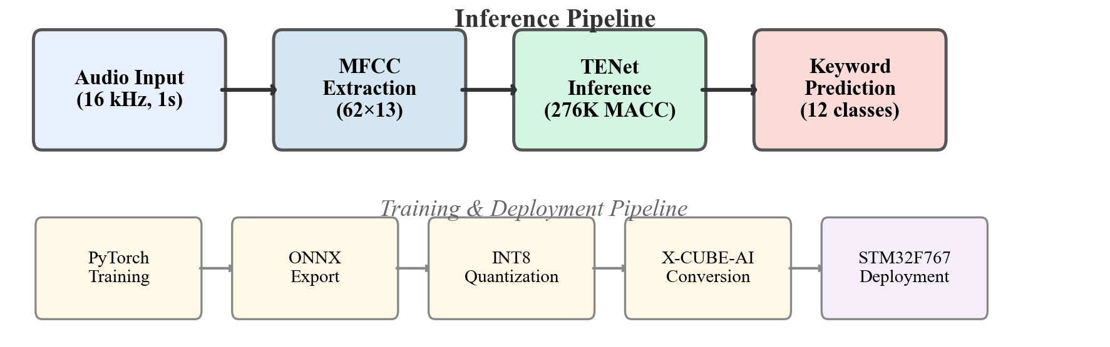
Fig. 1. System pipeline overview showing inference (top) and training/deployment (bottom) workflows.

B. Dataset
All experiments in this work are conducted using the Google Speech Commands Dataset v2 [1], which is widely used for benchmarking keyword spotting systems.
The classification task consists of 12 classes, including ten keyword commands (yes, no, up, down, left, right, on, off, stop, go) together with two additional classes (unknown and silence). The unknown class groups together speech samples that do not correspond to the target commands. The silence class consists of zero-padded waveforms generated to comprise approximately 10% of the base training dataset size.
Property | Value
Sampling rate | 16 kHz
Duration per sample | ~1 second (16,256 samples)
Training samples | ~51,000
Validation samples | ~13,000
Test samples | 12,105
Number of classes | 12

The dataset uses the official train/validation/test split provided by the dataset authors.

C. Feature Extraction
To convert raw audio signals into a representation suitable for neural network processing, Mel-Frequency Cepstral Coefficient (MFCC) features [7] are extracted from each audio sample using torchaudio.transforms.MFCC.
Parameter | Value
Number of MFCC coefficients (n_mfcc) | 13
Number of Mel filters (n_mels) | 16
FFT size (n_fft) | 512
Window length | 512
Hop length | 256
Minimum frequency (f_min) | 20 Hz
Center padding | False
Power | 2.0

These parameters produce an MFCC feature representation of 62 temporal frames × 13 coefficients per sample, resulting in an input tensor of shape (1, 62, 13) with a size of 3,224 bytes in float32 precision.

D. Architecture Selection
To identify the most efficient architecture for the target computational budget, five lightweight neural network architectures were evaluated under a constraint of approximately 287K MACCs. All models were trained for 50 epochs with identical training settings (AdamW, lr=0.001, batch size=1024) on the 12-class task.
Table I: Architecture comparison under ~287K MACC budget (50 epochs).
Architecture | Type | MACCs | Float32 Acc | INT8 Acc | INT8 Size
TENet [4] | 1D Inverted Bottleneck | 284,896 | 96.52% | 96.56% | 9.5 KB
LiCoNet | 1D Linearized Conv | 285,980 | 95.56% | 95.42% | 8.6 KB
CustomDSCNN | 2D Depthwise Separable | 286,240 | 94.71% | 94.49% | 6.3 KB
MobileNet-style | 2D MobileNet | 683,624 | 94.76% | 94.14% | 14.3 KB
BC-ResNet [5] | 2D Broadcast Residual | 290,008 | 83.85% | 71.84% | 2.3 KB

TENet achieved the highest accuracy (96.52%) and maintained excellent INT8 quantization robustness (96.56%), and was therefore selected as the base architecture for further optimization. BC-ResNet, despite its strong performance at larger scales [5], performed poorly at extreme channel reduction (channels as low as 4–12), likely due to insufficient capacity for its sub-spectral normalization mechanism.

E. TENet Architecture
The TENet architecture [4] processes MFCC sequences using one-dimensional temporal convolutions. The input tensor (1, 62, 13) is reshaped to (13, 62), treating the 13 MFCC coefficients as input channels and the 62 frames as the temporal dimension.
The architecture adopts an inverted bottleneck design inspired by MobileNetV2 [10], where each block consists of: (1) pointwise expansion Conv1d (in_ch → in_ch × ratio, kernel=1) to increase channel dimension; (2) depthwise temporal Conv1d (hidden, hidden, kernel=k, groups=hidden) for temporal feature extraction; (3) pointwise projection Conv1d (hidden → out_ch, kernel=1) for dimensionality reduction with no activation (linear); and (4) a residual connection (identity shortcut when stride=1 and in_ch=out_ch, otherwise a 1×1 projection shortcut).
The network begins with a stem convolution (Conv1d, kernel=3), followed by multiple inverted bottleneck stages, and concludes with adaptive average pooling and a fully connected classification layer. The optimized architecture parameters obtained through grid search (Section III.F) are shown in Table II.
Table II: Optimized TENet architecture parameters.
Parameter | Value
Stem channels | 14
Block channels | [14, 14, 14, 14, 14]
Strides | [2, 2, 1, 1]
Expansion ratios | [4, 4, 4, 4]
Layers per block | [1, 2, 1, 1]
Kernel size | 9
Dropout | 0.1
Total parameters | 12,822
Total MACCs | 276,136

Three key architectural design choices distinguish this configuration:
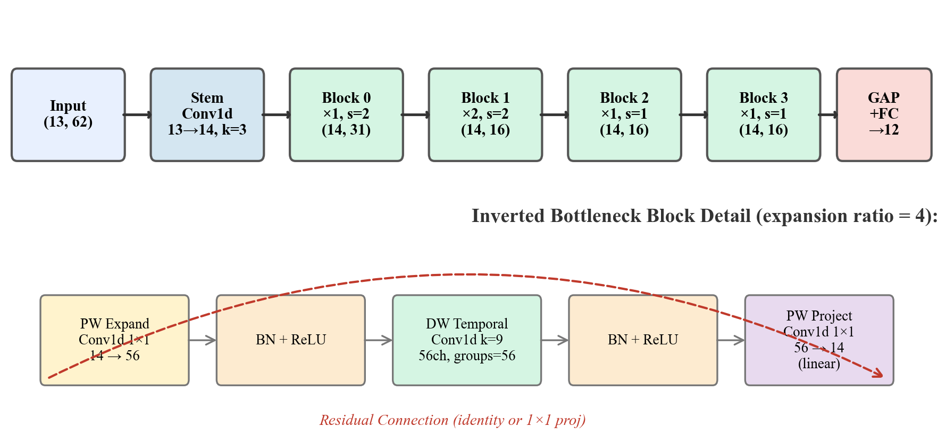
Fig. 2. TENet architecture: overall network structure (top) and inverted bottleneck block detail (bottom).
- Narrow channels with high expansion ratio (14 ch × 4× expansion): This creates a rich intermediate representation (56 channels) for depthwise convolutions while maintaining a compact bottleneck. This is more efficient than wider channels with lower expansion (e.g., 24 ch × 2×) at the same MACC budget.
- Double downsampling [2, 2, 1, 1]: Two stride-2 stages reduce the temporal dimension from 62 → 31 → 16 early in the network, allowing later blocks to operate on shorter sequences with 48% fewer temporal operations.
- Extra depth at mid-resolution (layers=[1, 2, 1, 1]): Placing an additional layer at the 31→16 transition provides greater representational capacity where information density is highest, at a cost of only ~52K additional MACCs.

F. Architecture Optimization
After selecting TENet as the base architecture, a four-stage progressive grid search was conducted to identify improved architectural configurations within the MACC budget of 287,673 (matching the DS-CNN baseline [9]).
The search explored six hyperparameters:
Dimension | Values Explored | Winner
Stem channels | {8, 12, 14, 16, 18, 20, 24} | 14
Block channels | {14, 16, 18, 20, 22, 24, 28, 32} | 14
Number of blocks | {2, 3, 4} | 4
Expansion ratio | {1, 2, 3, 4} | 4
Kernel size | {3, 5, 7, 9, 11, 13, 15} | 9
Layers per block | Various combinations | [1, 2, 1, 1]

Stride patterns were determined by the number of blocks: three candidate patterns per block count (e.g., [2,1,1,1], [2,2,1,1], [2,1,1,2] for 4 blocks). Any candidate exceeding the MACC budget was discarded before training.
The search was conducted in four progressive stages, summarized in Table III:
Table III: Four-stage progressive grid search strategy.
Stage | Candidates | Epochs | Augmentation | GPU Hours | Selection
Round 1 (Coarse) | 1,280 | 15 | None | 2.7 | Top val accuracy
Round 2a (Fine) | 548 | 15 | None | 1.1 | Expanded grid
Round 2b (Deep) | 464 | 200 | All (§III.G) | 12.0 | Val accuracy
Round 2c (Final) | 10 | 1,000 | All | 0.5 | Final ranking
Total | 2,302 | — | — | ~16 | —

All experiments were conducted on an NVIDIA RTX 5080 Laptop GPU with data preloaded to GPU VRAM for efficient small-model training. The progressive search strategy is conceptually related to successive halving [15], where computational resources are concentrated on the most promising candidates in later stages.
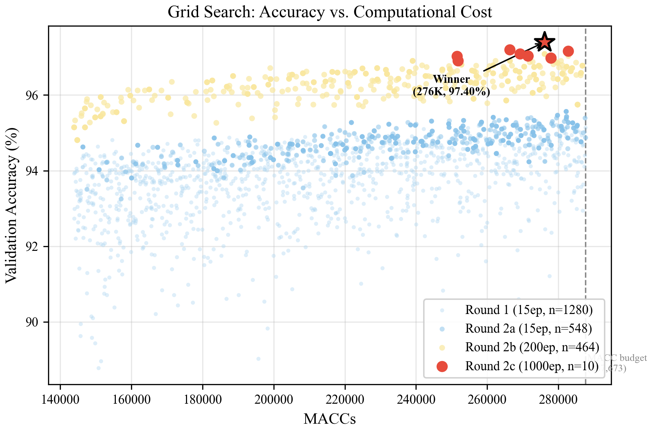
Fig. 3. Progressive grid search: accuracy vs. computational cost across four rounds (2,302 candidates).

G. Training Configuration
The final model was trained using the following configuration:
Parameter | Value
Optimizer | AdamW
Learning rate | 0.001
Weight decay | 1×10⁻⁴
Batch size | 1,024
Maximum epochs | 300
Best epoch | 273
Early stopping patience | 50 epochs
LR scheduler | CosineAnnealingLR + 5-epoch linear warmup
Minimum LR (η_min) | 1×10⁻⁵
Random seed | 123

Four data augmentation and regularization techniques were applied:
- SpecAugment [17]: 2 time masks (width=5 frames) and 1 frequency mask (width=2 bins) applied to MFCC features during training.
- Mixup [18]: Convex combination of training pairs with α=0.2, applied at the input level.
- Label smoothing [19]: Cross-entropy loss with smoothing factor ε=0.1.
- Cosine annealing [20]: Learning rate decayed from 0.001 to 10⁻⁵ following a cosine schedule after a 5-epoch linear warmup.
These techniques collectively contributed a +1.84 percentage point improvement in validation accuracy compared with training without augmentation (see Section IV.D for ablation results).
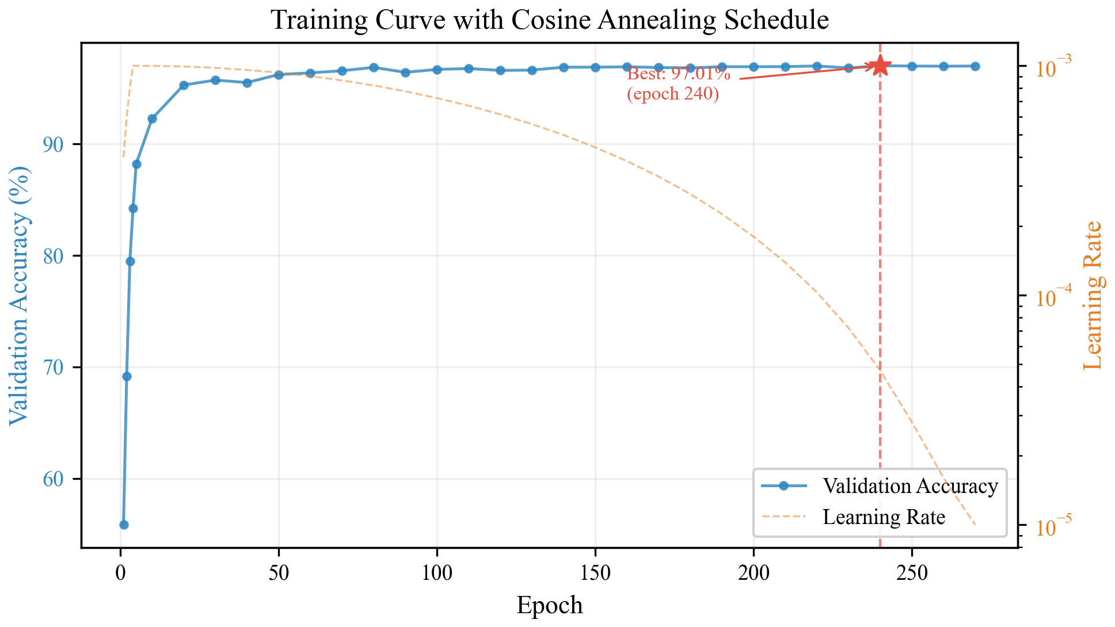
Fig. 5. Training curve showing validation accuracy and cosine annealing learning rate schedule over 273 epochs.

H. INT8 Quantization
Post-training static quantization was applied to convert the trained float32 model to INT8 precision for efficient embedded inference.
Parameter | Value
Tool | ONNX Runtime quantize_static
Quantization format | QDQ (QuantizeLinear/DequantizeLinear)
Activation type | QInt8 (signed 8-bit, per-tensor)
Weight type | QInt8 (signed 8-bit, per-channel)
Activation symmetric | False (asymmetric)
Weight symmetric | True
Calibration set | 200 random training samples (seed=42)
ONNX opset | 13

The QDQ format inserts explicit quantization and dequantization nodes in the ONNX graph, which is directly supported by the ST X-CUBE-AI conversion tool [8]. Per-channel weight quantization preserves accuracy better than per-tensor quantization for depthwise convolution layers.

I. Embedded Deployment
The quantized INT8 ONNX model was deployed on the STM32F767IGT6 microcontroller using ST X-CUBE-AI v2.2.0 [8].
Property | Value
MCU | STM32F767IGT6
Core | ARM Cortex-M7
Clock frequency | 216 MHz
Flash memory | 1 MB
SRAM | 512 KB
FPU | Single-precision
AI framework | X-CUBE-AI v2.2.0

The deployment pipeline consists of four steps: (1) training in PyTorch (float32); (2) export to ONNX format (opset 13); (3) INT8 quantization using ONNX Runtime (QDQ format); and (4) code generation using X-CUBE-AI, producing optimized C library and weight arrays. Inference latency is measured using the ARM DWT (Data Watchpoint and Trace) cycle counter, which provides cycle-accurate timing of the ai_run() function call.

IV. Results and Discussion

A. Experimental Setup
All models were trained using PyTorch 2.10.0 with CUDA on an NVIDIA RTX 5080 Laptop GPU. Evaluation was performed on the official test split of Google Speech Commands v2 (12,105 samples). Classification accuracy is computed as top-1 accuracy. F1-scores (weighted and macro) are computed using scikit-learn’s classification_report. All reported test accuracies are from a single training run with seed=123.

B. Classification Performance
Table IV presents the overall classification performance of the optimized TENet model in both float32 and INT8 precision.
Table IV: Overall classification performance.
Metric | Float32 | INT8 | Δ
Test Accuracy | 96.84% | 96.76% | −0.08%
Weighted F1 | 0.9683 | 0.9675 | −0.0008
Macro F1 | 0.9504 | 0.9490 | −0.0014
Macro Precision | 0.9604 | 0.9573 | −0.0031
Macro Recall | 0.9410 | 0.9411 | +0.0001

INT8 quantization causes only minimal accuracy degradation (−0.08%), demonstrating that the quantized model preserves the predictive capability of the floating-point model while enabling efficient embedded deployment.

C. Per-Class Analysis
Table V presents the per-class F1-scores for both float32 and INT8 models.
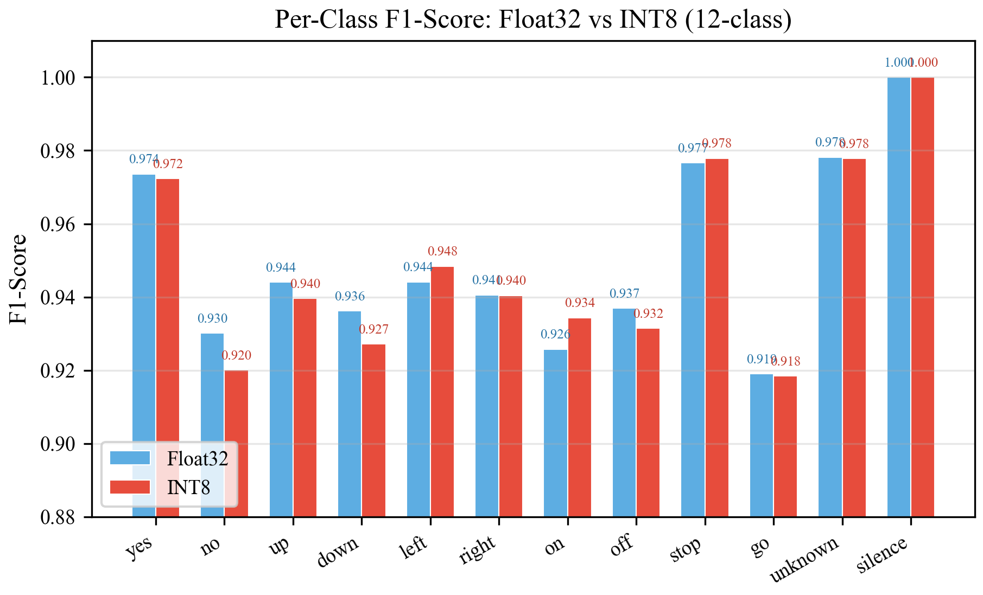
Fig. 4. Per-class F1-scores comparing Float32 and INT8 models across all 12 classes.
Table V: Per-class F1-scores (Float32 vs INT8).
Class | F1 (Float32) | F1 (INT8) | Δ F1 | Support
yes | 0.9736 | 0.9723 | −0.0013 | 419
no | 0.9302 | 0.9200 | −0.0102 | 405
up | 0.9440 | 0.9396 | −0.0044 | 425
down | 0.9362 | 0.9271 | −0.0091 | 406
left | 0.9441 | 0.9484 | +0.0043 | 412
right | 0.9406 | 0.9404 | −0.0002 | 396
on | 0.9258 | 0.9343 | +0.0085 | 396
off | 0.9370 | 0.9315 | −0.0055 | 402
stop | 0.9766 | 0.9779 | +0.0013 | 411
go | 0.9190 | 0.9184 | −0.0006 | 402
unknown | 0.9782 | 0.9778 | −0.0004 | 6,931
silence | 1.0000 | 1.0000 | 0.0000 | 1,100

The silence class achieves perfect classification (F1=1.000) in both precision modes. The highest keyword F1-scores are observed for stop (0.977) and yes (0.972), while go (0.918) and on (0.934) exhibit the lowest performance. The dominant error mode is confusion between keyword classes and the unknown class, which is expected given the acoustic similarity between target keywords and out-of-vocabulary speech.
The unknown class contains 6,931 samples (57.3% of the test set), and its high F1-score (0.978) substantially contributes to the weighted F1 metric. The macro F1-score (0.9490), which weights all classes equally, provides a more balanced assessment of per-class performance.
INT8 quantization produces minimal per-class variation: the maximum F1 degradation is 0.0102 (no class), while three classes (left, on, stop) show slight improvement after quantization, likely due to beneficial rounding effects.

D. Ablation Study: Training Optimization Impact
To quantify the contribution of training techniques, Table VI presents an ablation study comparing different training configurations.
Table VI: Ablation study of architecture optimization and training techniques.
Configuration | Val Acc | Test Acc | Δ vs. Previous
Baseline TENet (manual arch, no aug.) | 95.56% | 95.13% | —
Grid-optimized arch, no aug., 15 ep | 95.56% | — | +0.00%
Grid-optimized arch + all aug., 200 ep | 97.09% | — | +1.53%
Grid-optimized arch + all aug., 300 ep | 97.40% | 96.84% | +0.31%

The results show that architecture optimization alone provides a modest improvement when evaluated at short training horizons (15 epochs). Training augmentation techniques (SpecAugment, Mixup, label smoothing, cosine annealing) contribute +1.84% validation accuracy improvement, demonstrating that training methodology is as important as architecture design for small models. Extended training (300 epochs with early stopping at epoch 273) provides an additional +0.31% improvement.
The gap between validation accuracy (97.40%) and test accuracy (96.84%) is 0.56%, which is within the expected range for a single-seed evaluation and reflects the selection bias inherent in choosing the best architecture from 2,302 candidates.

E. Model Size and Deployment Metrics
Table VII: Model size and deployment metrics (INT8).
Metric | Value
Parameters | 12,822
MACCs (model) | 276,136
MACCs (X-CUBE-AI, incl. QDQ overhead) | 280,389
Flash memory (weights) | 13.87 KB
RAM (activations) | 7.64 KB
Firmware binary size | 67.4 KB
Weight compression vs. float32 | −70.8%

The MACC count reported by X-CUBE-AI (280,389) is slightly higher than the model-intrinsic count (276,136) due to additional operations introduced by QuantizeLinear and DequantizeLinear nodes in the INT8 inference graph.

F. On-Device Inference Latency
Inference latency was measured directly on the STM32F767IGT6 microcontroller using the DWT cycle counter.
Table VIII: On-device inference latency comparison.
Model | MCU | Clock | Latency | MACCs | Cycles/MACC
Ours (TENet INT8) | STM32F767 | 216 MHz | 6.32 ms | 276K | ~4.9
DS-CNN baseline [9] | STM32F769NI | 216 MHz | 7.00 ms | 288K | ~5.3

The optimized TENet model achieves 6.32 ms inference latency, which is 9.7% faster than the DS-CNN baseline despite operating on the same Cortex-M7 core at the same clock frequency. The ~4.9 cycles per MACC is consistent with INT8 mixed-precision inference on the Cortex-M7 architecture using X-CUBE-AI optimized kernels.

G. Comparison with State-of-the-Art
Table IX compares the proposed model with previously reported keyword spotting architectures. Two categories of comparison are presented: (1) models evaluated on GSCv2 12-class under similar MACC constraints, and (2) models deployed on microcontrollers with reported on-device metrics.
Table IX: Comparison with state-of-the-art keyword spotting models.
Model | Year | Params | MACCs | Accuracy | Flash | RAM | Latency | Platform
Ours (INT8) | 2026 | 12.8K | 276K | 96.76% | 13.87 KB | 7.64 KB | 6.32 ms | STM32F767 (M7@216MHz)
DS-CNN [9] | 2020 | ~6K | 288K | 91.00% | 169.63 KB | 11.52 KB | 7.00 ms | STM32F769NI (M7@216MHz)
DS-CNN-S [2] | 2018 | ~23K | 5.4M | 94.4%† | 38.6 KB | ~70 KB | ~12 ms | STM32F746 (M7@216MHz)
TENet12 [4] | 2020 | 100K | 2.9M | 96.8% | — | — | — | —
TENet6-N [4] | 2020 | 17K | 553K | 96.0% | — | — | — | —
BC-ResNet-1 [5] | 2021 | 9.2K | 3.1M | 96.9% | — | — | — | —
MatchboxNet [6] | 2020 | 93K | — | 97.48% | — | — | — | —
MLPerf Tiny [3] | 2021 | 38.6K | ~100K | ≥90% | — | ≤512 KB | ~182 ms | NUCLEO-L4R5ZI (M4@120MHz)

†Zhang et al. [2] evaluated on GSCv1, not GSCv2; results are not directly comparable.
Note: Bartoli et al. [21] recently evaluated several models (DS-CNN, TENet6, LiCoNet-S, TKWS) on STM32 platforms, reporting F1-scores of 91.2%–93.6%. However, their evaluation used an 8-class task with different MFCC configurations (15×63), making direct numerical comparison with our 12-class results inappropriate. Their study does confirm that TENet and LiCoNet architectures are more energy-efficient than DS-CNN on Cortex-M7 processors.
Compared with the DS-CNN baseline [9] evaluated on the same MCU architecture (Cortex-M7 at 216 MHz) under the same MACC constraint (~287K):
Metric | DS-CNN Baseline [9] | Ours (TENet INT8) | Improvement
Accuracy | 91.00% | 96.76% | +5.76 pp
Flash (weights) | 169.63 KB | 13.87 KB | −91.8%
RAM (activations) | 11.52 KB | 7.64 KB | −33.7%
Inference latency | 7.00 ms | 6.32 ms | −9.7%

Compared with the original TENet paper [4], our optimized variant achieves comparable accuracy (96.76% vs. 96.8% for TENet12+MTConv) while requiring approximately 10× fewer MACCs (276K vs. 2.9M). This demonstrates that systematic architecture optimization can recover most of the accuracy of larger models within a severely constrained computational budget.

V. Conclusion
This paper presented an optimized keyword spotting system designed for deployment on resource-constrained microcontrollers. Through a five-architecture comparison study and a four-stage progressive grid search over 2,302 candidate configurations, an optimized TENet variant was identified that achieves high classification accuracy within a strict computational budget of 276K MACCs.
The optimized model achieves 96.84% test accuracy (96.76% after INT8 quantization) and a weighted F1-score of 0.9675 on the Google Speech Commands v2 12-class benchmark, with only 12,822 parameters. When deployed on an STM32F767IGT6 Cortex-M7 microcontroller at 216 MHz, the INT8 model requires 13.87 KB of flash memory and 7.64 KB of RAM, and achieves an inference latency of 6.32 ms. Compared with the DS-CNN baseline operating under the same MACC constraint, the proposed model improves accuracy by 5.76 percentage points while reducing flash memory by 91.8%.
Key findings from this work include: (1) narrow channels with high expansion ratios are more efficient than wide channels with low expansion ratios at the same MACC budget; (2) training augmentation techniques (SpecAugment, Mixup, label smoothing) collectively contribute +1.84% accuracy improvement for small models; and (3) INT8 post-training quantization introduces negligible accuracy degradation (−0.08%) for the optimized architecture.
This work has several limitations. The evaluation is based on a single training seed, and the reported accuracy may vary by ±0.2–0.5% across different random initializations. Energy consumption was not measured, which is an important metric for battery-powered devices. The grid search approach, while effective for the six-dimensional space considered, does not scale to larger or continuous search spaces.
Future work will explore: (1) multi-seed evaluation to establish confidence intervals; (2) energy efficiency analysis using current measurement on the target hardware; (3) extension to streaming/continuous keyword spotting scenarios; (4) hardware-aware NAS methods (e.g., differentiable NAS, Bayesian optimization) to explore larger architecture spaces; and (5) deployment on additional MCU platforms including Cortex-M4 and RISC-V processors.

References
[1] P. Warden, "Speech commands: A dataset for limited-vocabulary speech recognition," arXiv preprint arXiv:1804.03209, 2018.
[2] Y. Zhang, N. Suda, L. Lai, and V. Chandra, "Hello edge: Keyword spotting on microcontrollers," arXiv preprint arXiv:1711.07128, 2017.
[3] C. Banbury et al., "MLPerf Tiny benchmark," in Proc. Neural Information Processing Systems (NeurIPS) Datasets and Benchmarks Track, 2021.
[4] R. Li, Z. Gao, L. Wang, and G. Li, "Small-footprint keyword spotting with multi-scale temporal convolution," in Proc. Interspeech, 2020.
[5] B. Kim, S. Chang, J. Lee, and D. Sung, "Broadcasted residual learning for efficient keyword spotting," in Proc. Interspeech, 2021.
[6] S. Majumdar and B. Ginsburg, "MatchboxNet: 1D time-channel separable convolutional neural network architecture for speech commands recognition," in Proc. Interspeech, 2020.
[7] S. Davis and P. Mermelstein, "Comparison of parametric representations for monosyllabic word recognition in continuously spoken sentences," IEEE Trans. Acoustics, Speech, and Signal Processing, vol. 28, no. 4, pp. 357–366, 1980.
[8] STMicroelectronics, "X-CUBE-AI: AI expansion pack for STM32CubeMX," 2024.
[9] P. M. Sorensen, B. Epp, and T. May, "A depthwise separable convolutional neural network for keyword spotting on an embedded system," EURASIP J. Audio, Speech, and Music Processing, vol. 2020, no. 1, pp. 1–11, 2020.
[10] M. Sandler, A. Howard, M. Zhu, A. Zhmoginov, and L.-C. Chen, "MobileNetV2: Inverted residuals and linear bottlenecks," in Proc. IEEE/CVF CVPR, 2018, pp. 4510–4520.
[11] J. Lin, W.-M. Chen, Y. Lin, J. Cohn, C. Gan, and S. Han, "MCUNet: Tiny deep learning on IoT devices," in Proc. NeurIPS, 2020.
[12] H. Liu, K. Simonyan, and Y. Yang, "DARTS: Differentiable architecture search," in Proc. ICLR, 2019.
[13] S. Liberatore, F. Pollicino, and M. Rusci, "MicroNAS: Zero-shot neural architecture search for MCUs," arXiv preprint arXiv:2401.08996, 2024.
[14] J. Bergstra and Y. Bengio, "Random search for hyper-parameter optimization," J. Machine Learning Research, vol. 13, pp. 281–305, 2012.
[15] K. Jamieson and A. Talwalkar, "Non-stochastic best arm identification and hyperparameter optimization," in Proc. AISTATS, 2016.
[16] L. Lai, N. Suda, and V. Chandra, "CMSIS-NN: Efficient neural networks on ARM Cortex-M processors," arXiv preprint arXiv:1801.06601, 2018.
[17] D. S. Park et al., "SpecAugment: A simple data augmentation method for automatic speech recognition," in Proc. Interspeech, 2019.
[18] H. Zhang, M. Cissé, Y. N. Dauphin, and D. Lopez-Paz, "Mixup: Beyond empirical risk minimization," in Proc. ICLR, 2018.
[19] C. Szegedy, V. Vanhoucke, S. Ioffe, J. Shlens, and Z. Wojna, "Rethinking the inception architecture for computer vision," in Proc. IEEE/CVF CVPR, 2016.
[20] I. Loshchilov and F. Hutter, "SGDR: Stochastic gradient descent with warm restarts," in Proc. ICLR, 2017.
[21] F. Bartoli, L. Boschi, and V. Luise, "End-to-end efficiency in keyword spotting: A system-level approach for embedded microcontrollers," arXiv preprint arXiv:2509.07051, 2025.

